
.
OUR LORD JESUS CHRIST, KING OF THE UNIVERSE  NOVEMBER 25, 2018

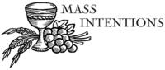
Sat. Nov. 24 VIGIL-OUR LORD JESUS CHRIST, KING OF THE UNIVERSE
4:00pm Pat LaBracio by Marilyn & Richard Croak

Sun. Nov. 25 OUR LORD JESUS CHRIST, KING OF THE UNIVERSE
8:30am For the People of the Parish
9:45am Mary Jo Kinner by Sal & Pat Manago

Mon. Nov. 26 WEEKDAY THIRTY-FOURTH WEEK IN ORDINARY TIME
8:30am Communion Service & Novena of the Miraculous Medal

Thurs. Nov. 29 WEEKDAY THIRTY-FOURTH WEEK IN ORDINARYTIME
8:30am Communion Service & Rosary

Sat. Dec. 1 VIGIL-FIRST SUNDAY OF ADVENT
4:00pm Evan Bozzo by Mary Knowles

Sun. Dec. 2 FIRST SUNDAY OF ADVENT
8:30am Marianne Proch by Ruth, Gail, & Susan Pilosi
9:45am For the People of the Parish

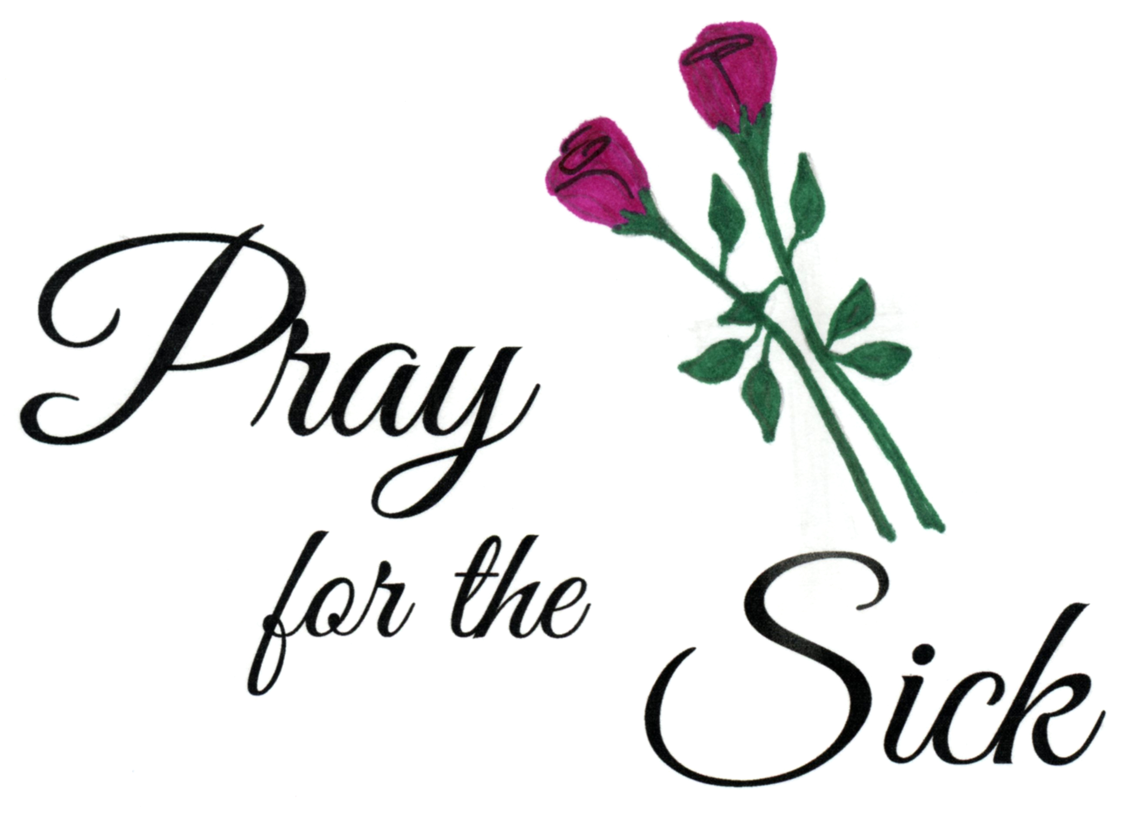
Parishioners who are sick and in need of prayers can be added to our prayer list by calling the Parish Office at 570-842-4995. Please pray for:Margaret Hollywood, Mary Duggan,
Ron Natoli, Father Vito, Gregory Tobin,
Reilly Canas, Lenny Olechna, Betsy Kressler, Joseph Ferenczi,
P.J. Cappola, Helen Zerbe, Paula Peet, Bob Jantz, Carmel Ann Maxson, Susan Golombos, Joseph Falchek, Jerry White, Donna Jean Marabella, Jeanne Tierney, Arline Chumacas, Jamie Jantz, Jenny Filingo,
Jennifer Simis, Alan Lemech, Phyllis Braun, Donna Lewis, Richard Major, Bill Vockroth, Vonette Castelblanco, Jane Colwell, Jeanne Kopyta,
Muriel Calame, Joanne Arredondo, Jason Scott Taylor, Vincent Natoli, and all the sick of the Parish.

Our Pilgrim Statue of the Blessed Virgin Mary

If she has not yet visited your home and you would like information or to sign up to have the Statue visit your home, please call Pat Manago at 570-848-2284.
This is where the statue will be traveling in the
weeks to come: 11/25-Bloss Family 12/02-Bloss Family
12/2-Bloss Family 12/09-Sanchez Family 12/16-OPEN 12/23-OPEN

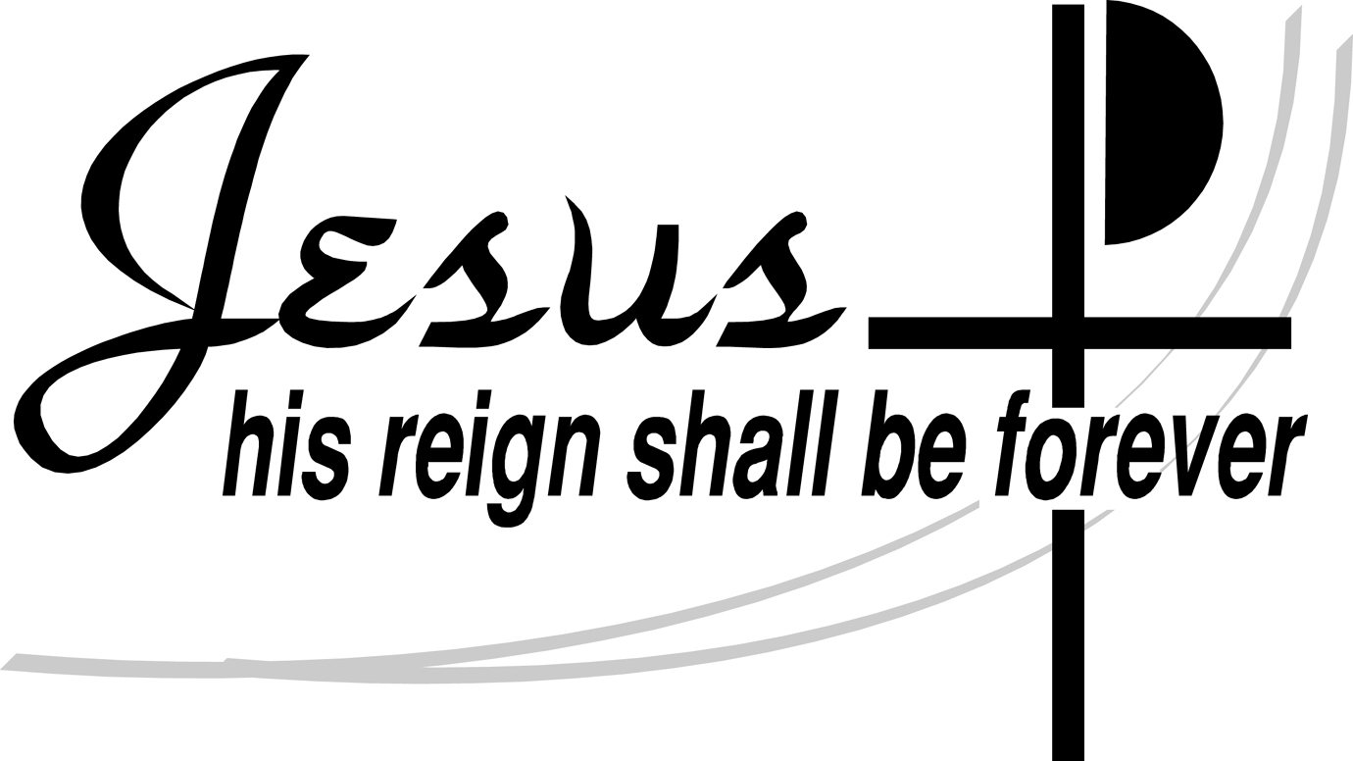


STEWARDSHIP OF TALENT:
Nov. 25, 2018 JESUS CHRIST, KING OF THE UNIVERSE
LECTORS:
Nov. 24th 4:00pm Mary Rounsavill
Nov. 25th 8:30am Mary Ann Chiodo
9:45am Kathlyn Engle
EXTRAORDINARY MINISTERS OF THE EUCHARIST:
Nov. 24th 4:00pm Sharon Lenzer/Pat Manago
Nov. 25th 8:30am Amanda Proch/Susan Pilosi
9:45am Kathy Fossetta/Daria Killian
ALTAR SERVERS:
Nov. 24th 4:00pm Alan Hynes
Nov. 25th 8:30am Veronica Yanulavich
9:45am Kathy Fossetta
HOSPITALITY & USHERS:
Nov. 24th 4:00pm Andy Kelemen/Victor Benfatti
Nov. 25th 8:30am Ed Snyder/Richard Colwell
9:45am Frank Kopyta/Richard Erazmus
Dec. 2, 2018 FIRST SUNDAY OF ADVENT
LECTORS:
Dec. 1st 4:00pm Bruce Negri
Dec. 2nd 8:30am Richard Colwell
9:45am Kathy Fossetta
EXTRAORDINARY MINISTERS OF THE EUCHARIST:
Dec. 1st 4:00pm Tony Butel/Mary Rounsavill
Dec. 2nd 8:30am Judy Martino/Susan Pilosi
9:45am Daria Killian/Marilyn Croak
ALTAR SERVERS:
Dec. 1st 4:00pm Alan Hynes
Dec. 2nd 8:30am Amanda Proch
9:45am Ayden Hull
HOSPITALITY & USHERS:
Dec. 1st 4:00pm Andy Kelemen/Victor Benfatti
Dec. 2nd 8:30am Richard Colwell/Tom Volpe
9:45am Richard Erazmus/Tom Quinn

STEWARDSHIP OF TREASURE:


11/18/18
ENVELOPES (63): $ 1305.00
LOOSE: $ 179.00
SCHOOL SUPPORT (1): $ 6.00
INSURANCE (33): $ 176.00
UTILITIES (2) $ 6.00
ONLINE (4): $ 53.00
TOTAL: $ 1725.00

CAMPAIGN FOR HUMAN DEVELOPMENT(21): $262.00

11/18 11/11 11/04 10/28
PEOPLE ATTENDING: 4:00PM 45 56 55 50
8:30AM 43 57 64 39
9:45AM 64 72 78 72

THANK YOU FOR YOUR CONTINUED SUPPORT!



ADVENT PENANCE SERVICE
DECEMBER 13, 2018
6:30PM

CHRISTMAS LITURGY SCHEDULE:
Christmas Eve -4:00 P.M. and 6:00 P.M.
Christmas Day-9:45 A.M.

January 1-SOLEMNITY OF MARY
Liturgy-9:00 A.M.

OPERATION SNOWFLAKE

Communion Services will be cancelled any time North Pocono School District
is delayed or cancelled. Weather delays and cancellations are broadcast on TV channels:
WNEP 16 – WYOU 22 – WBRE 28.


CLASSES FOR DECEMBER
DEC 2-FAITH FORMATION ROSARY-FAMILIES WELCOME
DEC 9-3RD AND 4TH GRADE FAMILY MASS
DEC 16 & 23-CLASSES

THE FAITH FORMATION PROGRAM IS
SPONSORING
CORPORAL WORKS OF MERCY
We support the Homeless by supporting the “Street to Feet” Homeless Day Center in Stroudsburg. They are currently in need of Coffee, Hot Cocoa, Shampoo, Soaps, Mini eyeglass fixers, Sewing kits, watches, mini first-aid kits and underwear in the larger sizes. If you would like to contribute to this ministry. Please bring any items you wish to donate to Church and leave them in the lower level of the Church or in the vestibule. Thank you for your help in this effort.
CHRISTMAS TOY DRIVE
We will be collecting toys for St. Vincent de Paul. Please drop off your donations at Church on the weekend or at the Rectory on Monday-Thursday from 9-1:30pm. We had a great response to this last year and hope we can be as successful this year.

Please pray for the repose of the soul of
Eleanor Dippel who died this past week.
Eternal rest grant unto her, O Lord
and let the Perpetual Light shine upon her.
And may the souls of all the faithful departed, through the mercy of God,
rest in Peace. Amen

Friends of the Poor Holiday Program Schedule Friends of the Poor will hold its annual holiday programming in November and December. All are welcome; however, pre-registration is required for the Toy Giveaway.
- Monday, December 3rd - Christmas Dinner for Adults and Elderly at St. Mary's Center 320 Mifflin Ave, Scranton, PA 18503; Doors open at 5PM ′
- Tuesday, December 18th - Christmas Toy Giveaway in Partnership with Catholic Social Services. Register with Catholic Social Services, 516 Fig Street, Scranton November 12th - 16th ′
- Thursday, December 20th - Family to Family Christmas Food Basket Program at St. Mary's Center 320 Mifflin Ave, Scranton, PA 18503; Doors open at 9AM
To volunteer for or donate towards these events, please call Friends of the Poor at 570-340-6086.


