
.
PENTECOST SUNDAY  MAY 20, 2018


Sat. May 19 VIGIL-PENTECOST SUNDAY
4:00pm For the People of the Parish

Sun. May 20 PENTECOST SUNDAY
8:30am Kaylan Sennefelder by Arlene Perrotti
9:45am Marge & Stephen Major

Mon. May 21 MEMORIAL OF THE BLESSED VIRGIN MARY
8:30am Communion Service & Novena to Saint Rita

Thurs. May 24 WEEKDAY IN ORDINARY TIME
8:30am Communion Service & Rosary

Sat. May 26 VIGIL-THE MOST HOLY TRINITY
4:00pm Winifred Maskarenitz by Michele Miley

Sun. May 27 THE MOST HOLY TRINITY
8:30am Dennis Stetz by M/M Stephen Proch
9:45am For the People of the Parish

Please pray for the repose of the soul of
Catherine Dunne who died this past week.
Eternal rest grant unto her, O Lord
and let the Perpetual Light shine upon her.
And may the souls of all the faithful departed,
through the mercy of God, rest in Peace. Amen

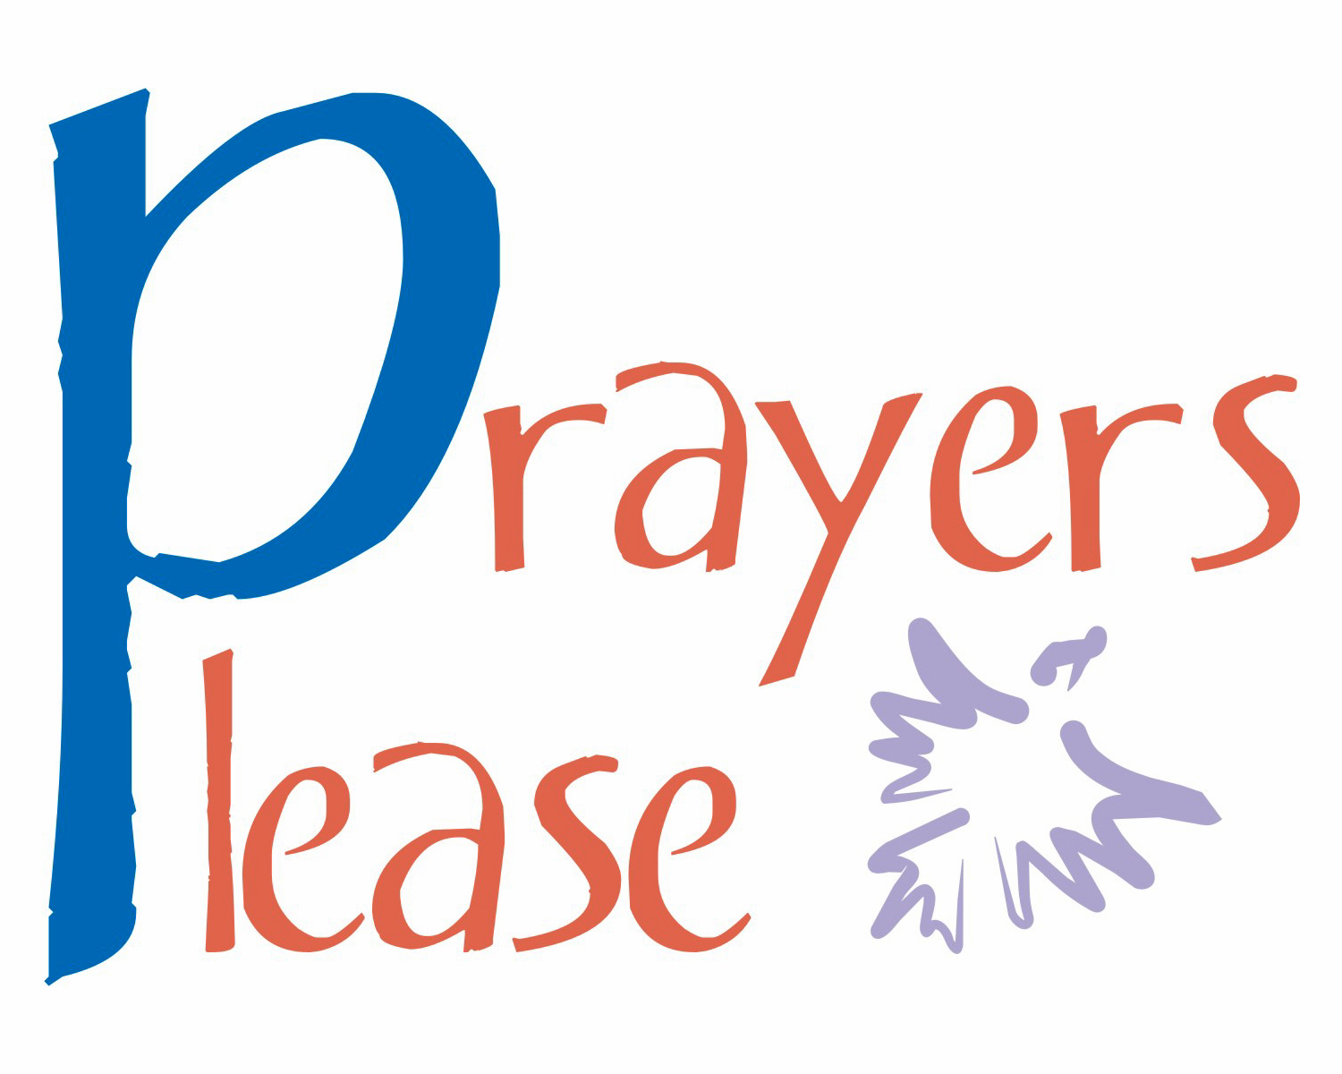
Parishioners who are sick and in need
of prayers can be added to our prayer
list by calling the Parish Office at
570-842-4995. Please pray for:
Tony Perrotti III, Lenny Olechna,
Betsy Kressler, Joseph Ferenczi,
P.J. Cappola, Helen Zerbe, Paula Peet, Carmel Ann Maxson,
Nicholas Pierotti, Susan Golombos, Bob Jantz, Joseph Falchek,
Donna Jean Marabella, Jeanne Tierney, Ben Topar, Pete Tambasco, Arline Chumacas, Jenny Filingo, Jerry White, Jennifer Simis,
Alan Lemech, Vincent Orazi, Phyllis Braun, Richard Major,
Vonette Castelblanco, Bill Vockroth, Jane Colwell, Jeanne Kopyta, Muriel Calame, Jamie Jantz, Donna Lewis, Jason Scott Taylor,
Joanne Arredondo, Vincent Natoli and all the sick of the Parish.

Our Pilgrim Statue of the Blessed Virgin Mary

If she has not yet visited your home and you would like information or to sign up to have the Statue visit your home, please call Pat Manago at 570-848-2284.
This is where the statue will be traveling in the
weeks to come: 5/20-Manago Family 5/27-Manago Family
6/03-Manago Family 6/10-Fossetta Family
6/17-OPEN 6/24-OPEN


May 20, 2018 PENTECOST SUNDAY
LECTORS:
May 19th 4:00pm Ed Kosmahl
May 20th 8::30am Jim Kohn
9:45am Daria Killian
EXTRAORDINARY MINISTERS OF THE EUCHARIST:
May 19th 4:00pm Ron Natoli/Lyne Van Houtte
May 20th 8:30am Tony Butel/Susan Pilosi
9:45am Tony Butel/Amanda Proch
ALTAR SERVERS:
May 19th 4:00pm Alan Hynes
May 20th 8:30am Veronica Yanulavich
9:45am Kathy Fossetta
HOSPITALITY & USHERS:
May 19th 4:00pm Andy Kelemen/Victor Benfatti
May 20th 8:30am Richard Colwell/Tom Volpe
9:45am Richard Erazmus/Tom Quinn
May 27, 2018 THE MOST HOLY TRINITY
LECTORS:
May 26^{h} 4:00pm Lyne Van Houtte
May 27th 8::30am Richard Colwell
9:45am Sharon Lenzer
EXTRAORDINARY MINISTERS OF THE EUCHARIST:
May 26th 4:00pm Tony Butel/Mary Rounsavill
May 27th 8:30am Amanda Proch/Veronica Yanulavich
9:45am Daria Killian/Kathy Fossetta
ALTAR SERVERS:
May 26th 4:00pm Alan Hynes
May 27th 8:30am Susan Pilosi
9:45am Ayden Hull
HOSPITALITY & USHERS:
May 26th 4:00pm Andy Kelemen/Victor Benfatti
May 27th 8:30am Ed Snyder/Tom Volpe
9:45am Frank Kopyta/Tom Quinn

STEWARDSHIP OF TREASURE:


5/13/18
ENVELOPES (67): $ 1064.00
LOOSE: $ 462.00
SUPPLEMENTARY (1): $ 50.00
SCHOOL DEBT (33): $ 221.00
ASCENSION (23): $ 236.00
ONLINE (1): $ 28.00
TOTAL: $ 2061.00

05/13 05/06 04/29 04/21
PEOPLE ATTENDING: 4:00PM 64 56 96 60
8:30AM 61 64 52 63
9:45AM 45 63 83 80

THANK YOU FOR YOUR CONTINUED SUPPORT!
To meet our weekly obligations, our approximate
weekly income needs to be $2500.00.


BASKET RAFFLE TO BE HELD FROM MAY 26 THROUGH JUNE 17
If anyone would like to donate a Basket to this fundraiser, please contact the Parish Office at 570-842-4995. The Basket Raffle will begin on Memorial Day Weekend and continue till June 17 when we will draw the winners.
PLEASE NOTE: WE NEED VOLUNTEERS TO HELP SELL TICKETS FOR THIS RAFFLE. THERE IS A SCHEDULE IN THE VESTIBULE FOR ANYONE TO SIGN UP. WE ARE ONLY ASKING THAT YOU SIGN UP FOR 2-HOUR SHIFTS.
THANK YOU FOR YOUR HELP!


SAINT RITA BUS TRIP TO THE SANDS CASINO, BETHLEHEM
WHEN: June 13, 2018
Bus leaves Saint Rita at 10:00am and will return at 5:15pm. COST: $25.00 per person, REBATES: $20.00 in slot play and $5.00 in food money. Sponsored by Saint Rita Church. For information and reservations call Mary at 570-676-3711 or the Parish Office at 570-842-4995.

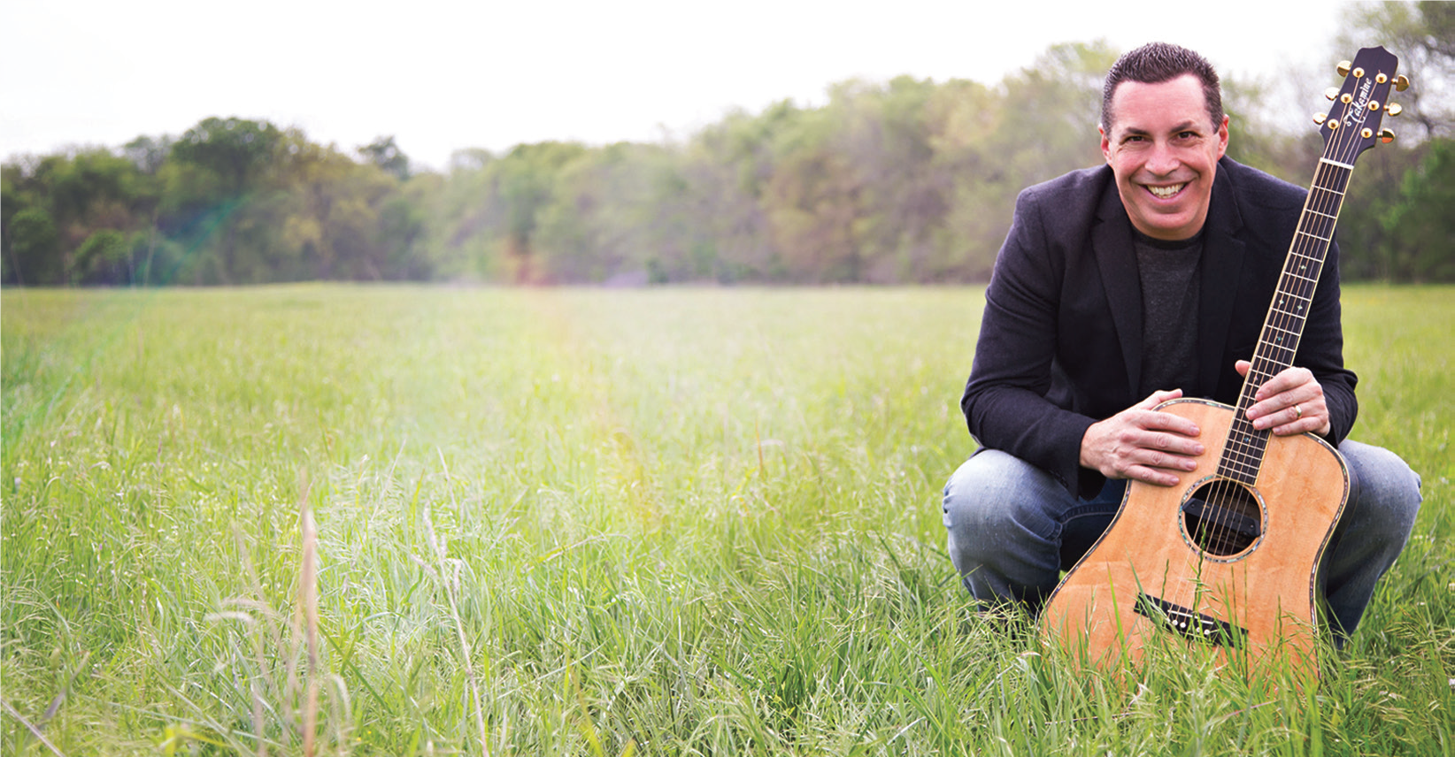
STEVE ANGRISANO CONCERT
FRIDAY, JUNE 15
7PM AT ST. MARK’S

Steve Angrisano is one of the most effective and versatile ministry leaders in the Church today. People of all ages embrace the passionate message of faith woven throughout his music and storytelling. As a consummate musician and master storyteller, Steve captivates young and old alike with an inspiring message of passion and faith. This is not an event that requires the kids to go in one room, the teens to another, the adults in yet another.
This event is being hosted by St. Elizabeth Parish in Bear Creek and St. Rita Parish in Gouldsboro. If you would like more information you may call 570-842-4995. There is no admission charge, all are welcome. A free-will offering will be taken up at the event.


YOUR YEARLY ENVELOPES ARE HERE
We ordered envelopes for all our registered parishioners. Please check the lower level of the Church if you have not yet picked yours up!

Catholic Women’s Conference
“REFRESH YOUR FAITH”
SATURDAY, JUNE 23
8:30AM-4:00PM
University of Scranton, Byron Center
820 Mulberry St, Scranton
Early Registration $40, after June 1 $50
Student fee $20 Register online at http://www.dioceseofscranton.org/catholic-womens-conference/

ONLINE GIVING NOW AVAILABLE AT ST. RITA PARISH :
www.stritaspa.org.

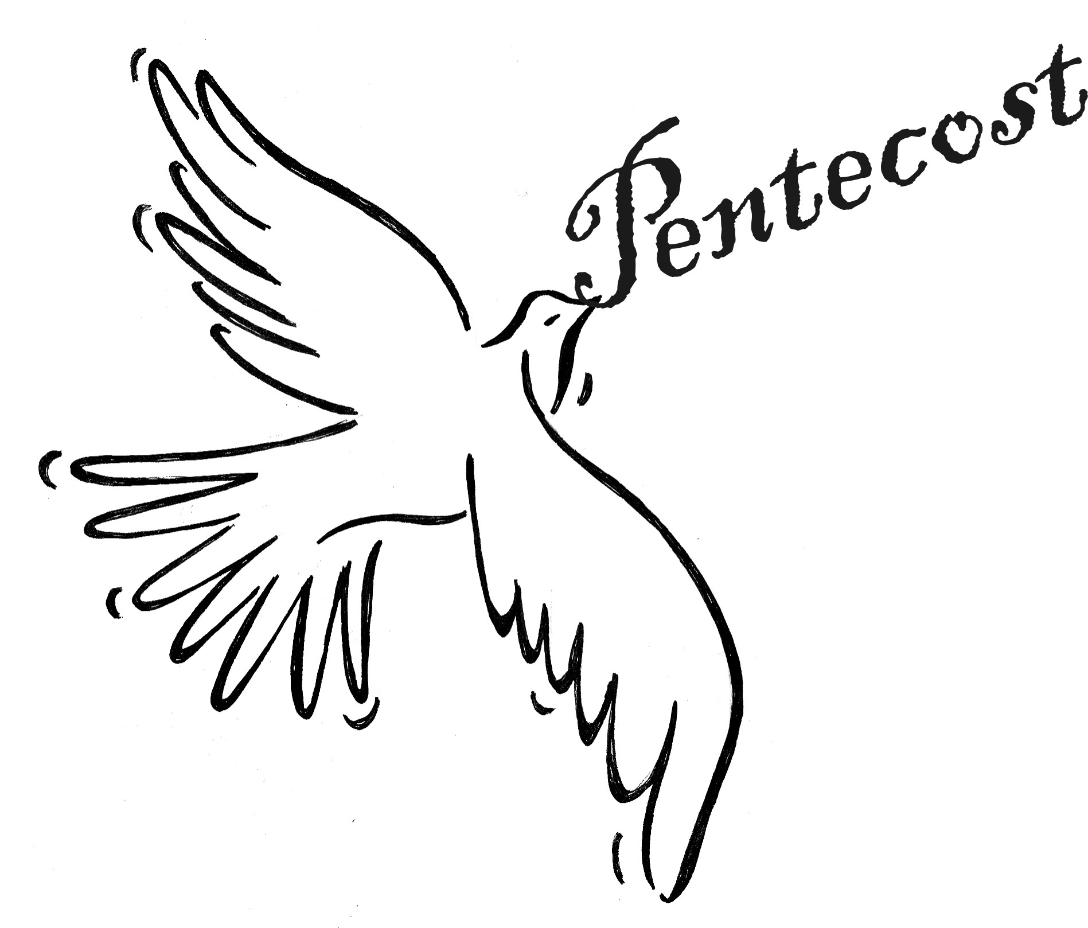

A PRAYERFUL MOMENT
Text, Philip J. Sandstrom, S.T.D.

VENI CREATOR SPIRITUS!
“Holy Spirit, the Lord and life-giver.” These words are in the Creed. Today we celebrate the coming of the Holy Spirit; he came to bestow a share in divine life upon God’s chosen and covenanted people. There is sound, wind and fiery light as signs of the gift. People experience the reversal of the fall of Babel. Everyone hears in his or her own language the Apostles speaking. They speak about the marvels of God. The Spirit is given to each for a good purpose—building up Christ’s body.
Veni Creator Spiritus!

