
.
THIRTY-THIRD SUNDAY IN ORDINARY TIME  NOVEMBER 18, 2018



Sat. Nov. 17 VIGIL-THIRTY-THIRD SUNDAY IN ORDINARY TIME
4:00pm Michael Kelly by Ron & Marie Natoli

Sun. Nov. 18 THIRTY-THIRD SUNDAY IN ORDINARY TIME
8:30am Vincent Chiodo by Mary Ann Chiodo
9:45am For the People of the Parish

Mon. Nov. 19 WEEKDAY THIRTY-THIRD WEEK IN ORDINARY TIME
8:30am Communion Service & Novena of the Miraculous Medal

Thurs. Nov. 22 SAINT CECILIA, VIRGIN & MARTYR
8:30am NO SERVICE ON THANKSGIVING DAY

Sat. Nov. 24 VIGIL-OUR LORD JESUS CHRIST, KING OF THE UNIVERSE
4:00pm Pat LaBracio by Marilyn & Richard Croak

Sun. Nov. 25 OUR LORD JESUS CHRIST, KING OF THE UNIVERSE
8:30am For the People of the Parish
9:45am Mary Jo Kinner by Sal & Pat Manago


PASTORAL COUNCIL
MONDAY, NOV 19
6”30 PM

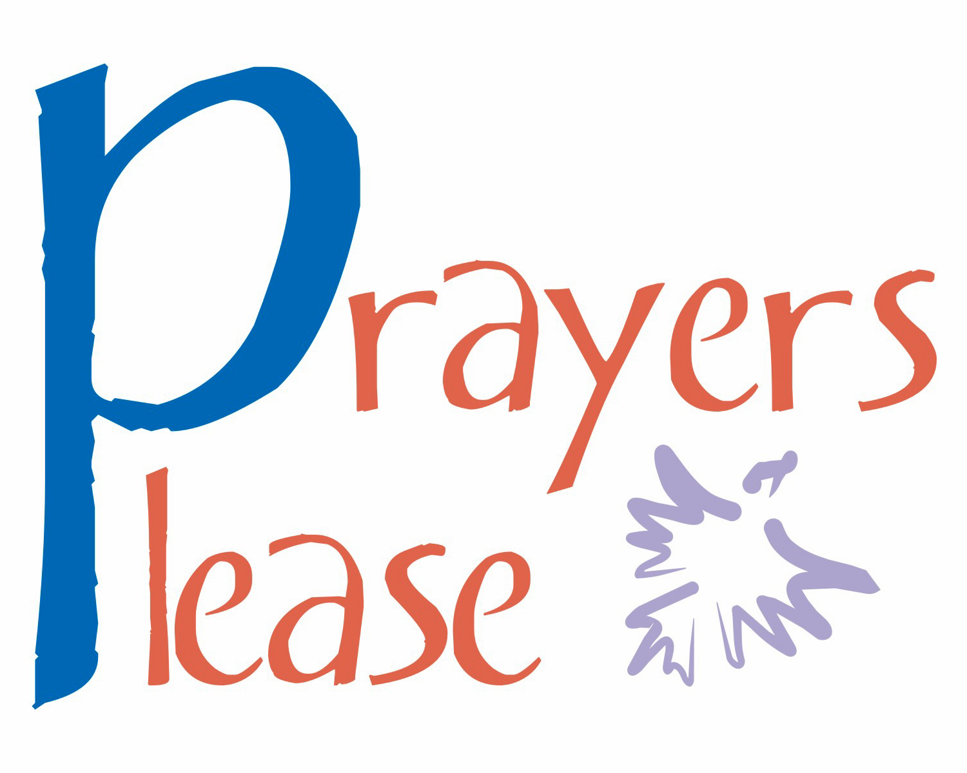
Parishioners who are sick and in need of prayers can be added to our prayer list by calling the Parish Office at 570-842-4995. Please pray for:Margaret Hollywood, Mary Duggan,
Ron Natoli, Father Vito, Gregory Tobin,
Reilly Canas, Lenny Olechna, Betsy Kressler, Joseph Ferenczi, P.J. Cappola, Helen Zerbe, Paula Peet, Bob Jantz, Carmel Ann Maxson, Susan Golombos, Joseph Falchek, Jerry White, Donna Jean Marabella, Jeanne Tierney, Arline Chumacas, Jamie Jantz, Jenny Filingo, Jennifer Simis, Alan Lemech, Phyllis Braun, Donna Lewis, Richard Major, Bill Vockroth, Vonette Castelblanco, Jane Colwell,
Jeanne Kopyta, Muriel Calame, Joanne Arredondo, Jason Scott Taylor, Vincent Natoli, and all the sick of the Parish.

Our Pilgrim Statue of the Blessed Virgin Mary

If she has not yet visited your home and you would like information or to sign up to have the Statue visit your home, please call Pat Manago at 570-848-2284.
This is where the statue will be traveling in the
weeks to come: 11/18-Croak Family 11/25-Bloss Family 12/02-Bloss Family 12/09-Sanchez Family
12/16-OPEN 12/23-OPEN


STEWARDSHIP OF TALENT:
Nov. 18, 2018 THIRTY-THIRD SUNDAY IN ORDINARY TIME
LECTORS:
Nov. 17th 4:00pm Ed Kosmahl
Nov. 18th 8:30am Pat Manago
9:45am Brielle Ostrowski
EXTRAORDINARY MINISTERS OF THE EUCHARIST:
Nov. 17th 4:00pm Tony Butel/Lyne Van Houtte
Nov. 18th 8:30am Amanda Proch/Veronica Yanulavich
9:45am Kathy Fossetta/Marilyn Croak
ALTAR SERVERS:
Nov. 17th 4:00pm Alan Hynes
Nov. 18th 8:30am Susan Pilosi
9:45am Ayden Hull
HOSPITALITY & USHERS:
Nov. 17th 4:00pm Andy Kelemen/Victor Benfatti
Nov. 18th 8:30am Tom Volpe/Richard Colwell
9:45am Tom Quinn/Richard Erazmus
Nov. 25, 2018 JESUS CHRIST, KING OF THE UNIVERSE
LECTORS:
Nov. 24th 4:00pm Mary Rounsavill
Nov. 25th 8:30am Mary Ann Chiodo
9:45am Kathlyn Engle
EXTRAORDINARY MINISTERS OF THE EUCHARIST:
Nov. 24th 4:00pm Sharon Lenzer/Pat Manago
Nov. 25th 8:30am Amanda Proch/Susan Pilosi
9:45am Kathy Fossetta/Daria Killian
ALTAR SERVERS:
Nov. 24th 4:00pm Alan Hynes
Nov. 25th 8:30am Veronica Yanulavich
9:45am Kathy Fossetta
HOSPITALITY & USHERS:
Nov. 24th 4:00pm Andy Kelemen/Victor Benfatti
Nov. 25th 8:30am Ed Snyder/Richard Colwell
9:45am Frank Kopyta/Richard Erazmus

STEWARDSHIP OF TREASURE:


11/11/18
ENVELOPES (74): $ 1596.00
LOOSE: $ 298.00
FUEL (1): $ 10.00
DEBT REDUCT (1): $ 60 00
UTILITIES (45) $ 375.00
ONLINE (6): $ 183.00
TOTAL: $ 2522.00

11/11 11/04 10/28 10/21
PEOPLE ATTENDING: 4:00PM 56 55 50 68
8:30AM 57 64 39 53
9:45AM 72 78 72 58

THANK YOU FOR YOUR CONTINUED SUPPORT!


CLASSES FOR NOVEMBER
11/11, 11/18

THE FAITH FORMATION PROGRAM IS
SPONSORING
CORPORAL WORKS OF MERCY
We support the Homeless by supporting the “Street to Feet” Homeless Day Center in Stroudsburg. They are currently in need of Coffee, Hot Cocoa, Shampoo, Soaps, Mini eyeglass fixers, Sewing kits, watches, mini first-aid kits and underwear in the larger sizes. If you would like to contribute to this ministry. Please bring any items you wish to donate to Church and leave them in the lower level of the Church or in the vestibule. Thank you for your help in this effort.

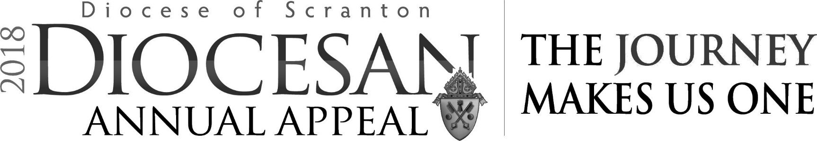
Every donation counts!!
If you have not yet pledged, please...
Help us reach our Annual Appeal Parish Goal!
Our Parish is at
55%
GOAL: $15,000.00
PLEDGED: $ 8,158.00
UNDER: $ 6,842.00
Our Parish is reimbursed 75% for any
gift in excess of our Appeal goal.

Please pray for the repose of the soul of
Eleanor Dippel who died this week.
Eternal rest grant unto her, O Lord
and let the Perpetual Light shine upon her.
And may the souls of all the faithful departed,
through the mercy of God, rest in Peace. Amen
GRIEF SUPPORT GROUP
The Group meets every Wednesday from noon to 1:00 pm in the Carriage House at St. Catherine's Church, 220 Church Street, Moscow, PA. We run a six-week program with different topics offered each week for discussion. The next program will begin on Wednesday, November 28, 2018. We explore the misconceptions of grief, coping techniques, exploring feelings of loss, how to take care of ourselves during this time and other topics. We offer a great set of ears and an opportunity to connect with others going through the pain of loss. Come join us. To ask questions or to register call St. Catherine's Church office at 570-842-4561 and ask for Cindy Purcell.

GRACE LUTHERAN CHURCH,
GOULDSBORO, FOOD PANTRY PROGRAM
The Church is asking for assistance on the 4th Monday of every month unloading a food truck delivery and stocking shelves from 10am-12pm. If you are able to volunteer pleas call Anissa at 570-445-7466.

Notice Regarding Reporting Sexual Abuse of a Minor
It is the policy of the Diocese of Scranton to report any allegation of sexual abuse of a minor to law enforcement. If you are a victim of sexual abuse committed by a priest, deacon, religious or lay employee or volunteer of the Diocese of Scranton, you are encouraged to immediately report the matter to law enforcement. If any priest, deacon, religious, lay employee or volunteer of the Diocese of Scranton has cause or reason to suspect that a minor has been subjected to any form of abuse, including child sexual abuse, the matter will be reported to law enforcement. In accordance with the Commonwealth of Pennsylvania’s Child Protective Service Laws, reports of suspected child abuse should also be made immediately by phone to the 24-Hour Child Abuse hotline (ChildLine) at 1-800-932-0313 or electronically at www.compass.state.pa.us/cwis.
It is also the policy of the Diocese to adhere to all civil and state regulations. To this end, the Diocese is equally committed to adhering to the norms of the Code of Canon Law and to upholding the tenets of the USCCB Charter for the Protection of Children and Young People, which includes supporting victims of sexual abuse in their pursuit of emotional and spiritual well-being. As such, information regarding an allegation of sexual abuse of a minor should also be reported to the Victim Assistance Coordinator Mary Beth Pacuska at 570-862-7551 or to Diocesan officials, including the Vicar General, Monsignor Thomas M. Muldowney, V.G., at 570-207-2269.

